Suitable Sustainable Municipal Solid Waste Management Approach for Kathmandu
Akansha Gupta
Department of Architecture & Urban Planning, Energy for sustainable Social Development ,Central Campus, Institute of Engineering, Tribhuvan University, Nepal Corresponding Email: akanshagupta_072mses451@ioe.edu.np

Abstract: With the growing population due to urbanization and industrialization in most of the cities of the world, the amount of Municipal Waste Generation is also increasing. The composition of these wastes is also changing due to factors such as change in lifestyle, economic development, consumption pattern etc. On top of that open dumping is practiced heavily as a method for municipal disposal worldwide. This leads to unsustainable way of handling the Municipal Solid Waste. There are approaches available which helps in the sustainable solid waste management. But the selection of strategies has to be tactfully thought beforehand that the failure in the application can be avoided. Hence, this paper has the aim of recognizing which approach available is best fit in the context of Kathmandu.

Key words: Sustainable Solid Waste Management, MSW (Municipal Solid Waste), RFID (Radio Frequency Identification), RDF (Refuse Derived Fuel), Hybrid Gasification and Incineration, PAYT (Pay As You Throw)

1. Introduction
Globally cities face environmental challenges and have to deal with the climate change issues. Urbanization is taking place at a high rate and along with it comes the rapid population growth and the increase demand of energy. Not only the consumption demand increases but the waste production that it brings is embarking. The situation worsens with the inefficient way to handle the growing waste production and can become a burden. The environmental issues and health hazards by haphazard management of Municipal Solid Waste (MSW) is converging the focus of the people towards sustainability in al perspective. The main idea is that cities should be deal all the aspects such as use of water resources, management of solid waste, use of energy, consumption of energy etc. with a vision of sustainability.
Solid waste management (SWM) is one of the major environmental issues in cities of many developing countries, including Nepal. Urban population growth and economic development lead to increasing generation of municipal solid waste (MSW). On one hand, the population is increasing at a high rate but on the other hand, no efficient ways of tackling with the waste produced are considered which is creating a burden not only at the local level but at the global level as well. Rapid and haphazard urbanization, lack of public awareness, and poor management by municipalities have intensified environmental problems in cities in Nepal, including unsanitary waste management and disposal. While solid waste management (SWM) has become a major concern for municipalities and the country as a whole. Environmental pollution as well as health hazards is derived from unsanitary solid waste management. The approach to deal with municipal solid waste in a sustainable manner in not only the work of government’s side but has to be dealt from the local level for the appropriate and successful results. Unmanaged disposal of wastes contribute to pollution and public health hazards in the localities. Therefore, SWM has become a major concern for the municipalities of Nepal as sustainable municipal waste management has the ability to not only reduce GHG emissions and drop the CO2 and methane gas into the environment, thus ensures the health of the people and a clean environment.

2. Objective
Main objectives:
- To find the sustainable approach of Solid Waste Management.

Specific objectives:
- To determine the current practices of municipal SWM in Kathmandu.
- To recognize the possible ways of sustainable Solid Waste Management approaches.
- To identify and analyze which approach of sustainable solid waste management best fit in context of Kathmandu.
4. Methodology
The research is based on the literature review. The research has attempted to make an explanation on ‘How’ the solid waste produced in the Kathmandu City be managed in a sustainable manner. Relevant literature review was done and then the data was analyzed to find out which are the solutions that are best fit in the context of Kathmandu in terms of Municipal Solid Waste Management.

5. Study Area

Kathmandu valley was taken as the study area. It is the capital of Nepal.

6. Rationale of Selection of Study Area
More population and their consumption pattern give rise to more production of solid waste. Kathmandu city being the capital of Nepal is prone to urbanization at a very high rate. As per the data collected Kathmandu Valley has 9% of total population of Nepal and has the rate of urbanization as 4.35% which is higher than the rate of urbanization of Nepal which is 3.62% (Rajbhandari US, 2014).
With the growing urbanization and industrialization the economic level of the people also rise with give rise to change in consumption pattern and thereby producing the composition of Solid Waste as well. Though the urbanization rate is high in valley, the planning and management of SWM is very weak. The practices such as haphazard dumping of the municipal waste into rivers, collecting and incinerating the municipal waste in an open space without the segregation of combustible and non- combustible waste and no segregation of biodegradable and non-degradable waste before dumping to the landfill area are inviting health hazards to the people as well as threatening the global environment.
With the rapid urbanization and unplanned waste management in the capital, it is facing the problem of SWM system which is projected to worsen in the future years to come with even more population residing and the poor management of waste which is prevailing. Hence, Kathmandu is selected as the area of study so that possible appropriate solutions can be drawn to reverse the city of waste to an eco-city through the planning of SWM.

7. Validity of research:
In spite of the large potential of SWM system in contribution to clean and a healthy city, much remains yet to be achieved. Though the prevailing SWM system has been studied previously, the way of handling municipal waste from the perspective of sustainability in Kathmandu is yet to be discovered. Thus, this research is validated.

8. Literature Review
8.1. Present Scenario of SWM in Kathmandu
8.1.1. Municipal Solid Waste Generation and Composition
The average composition of MSW from three sources i.e. Household Waste, Institutional waste and Commercial Waste is as follows: organic waste 56%, plastics 16%, paper and paper products 16%, glass 3%, metals 2%, textiles 2%, rubber and leather 1%, and others 4%. The analysis of waste composition showed that organic matter accounted for the highest fraction, making up 66% of household waste and 43% of commercial waste; while the largest fraction for institutional waste was paper and paper products at 44%. The survey showed that there is great potential to promote composting of MSW in all municipalities. (Solid Waste Management in Nepal., 2013).

8.1.2. Existing Solid Waste Management System
- Collection and segregation
The study found that about 30% of surveyed households in the municipalities practice segregation of waste at source. Analyzing the information provided by the municipalities, the present collection efficiency ranges between 70% and 90% in major towns . However, this may be overestimated by the municipalities due to the lack of scientific recording systems. Citizens dispose of waste within their compound either by unscientific composting, open burning, or throwing the waste in the surrounding open space. Collection, city cleaning, and sweeping is not done on a daily basis except in main markets, along main roads, as well as in residential areas. (Solid Waste Management in Nepal., 2013).

- Transport and Final Disposal
The vehicles and equipment available for waste collection and transport in each municipality varies widely. Vehicles commonly used include rickshaws and carts for primary collection, tractors for secondary collection or transport, and dump trucks for transport to the disposal sites. Open dumping, including riverside and roadside dumping, is heavily practiced creating public health risks and environmental problems. KMC and Lalitpur are facing the problems including frequent local protests, lack of proper management, and unavailability of necessary equipment, leading to unsanitary methods of disposal.

8.1.3. Solid Waste Management Policy and Legislation
Among the acts and policies pertaining to SWM, the 2011 Solid Waste Management Act and the 1996 National Policy on SWM are particularly relevant. The National Policy on SWM was formulated in 1996 to address the emerging SWM problems due to urbanization. The policy emphasizes waste management in municipal and urban areas and is still in force. Its main objectives are to (i) make SWM simple and effective, (ii) minimize the impact of solid waste on the environment and public health, (iii) treat solid waste as a resource, (iv) include private sector participation, and (v) improve public participation by increasing public awareness about sanitation.

8.1. Different Approaches for sustainable Solid Waste Management
There are many approaches towards sustainable solid waste management. The approach can be from various stages from decision making level, management level to system involved in carrying out the waste management level.

8.1.1. Life Cycle Assessment of Reusing Fly Ash from Municipal Solid Waste: A Case of Taiwan.
Fly ash is the residual substance that is left after the incineration of Municipal Solid Waste. As landfill capacity in the country is limited, this vast amount of fly ash should ideally be reused. However, fly ash has worse impact on the environment because of which some treatment methods should be applied before using fly ash. There are three types of treatment methods available:1) Extraction and separation,2) Thermal treatment, and 3) Stabilization/solidification. Amongst all these methods, thermal treatment has the maximum efficiency but expensive. Extraction and separation methods are the simplest but it requires a lot of energy consumption. The stabilization method is thus the most appropriate in terms of efficiency as well as cost-effectiveness. These methods separate out the hazardous components such as dioxides, furans and heavy metals such as Lead and Zinc. There are various process of reusing the fly ash. Four of them are: 1) landfill after solidification, 2) reuse as cement after a washing process, 3) reuse as bricks after a washing process, 4) reuse as alkaline in the waelz process of steelmaking.

A case study was carried out in Taiwan for realizing the best process of reuse of fly ash from MSW by assessing the impact on environment.
- Characteristics of fly ash from MSW incineration
MSW fly ash is composed of many toxic substances, with the majority metal salts, but the composition of fly ash does differ somewhat from country to country. The fly ash was collected from the incineration of MSW in northern Taiwan. It was found that the major components of this fly ash were 22.08% SiO2 and 12.44% CaO.
- Life cycle assessment framework
The environmental impact of fly ash was compared in four processes of reuses of fly ash. Life Cycle Assessment framework is the tool which was used to identify the best process of reuse of fly ash.

- Impact assessment: scenarios
1) Scenario 1: Landfill after solidification
The most common treatment of fly ash in Asia is disposal to landfills after solidification. After the washing process, the fly ash is mixed with cement and a chelating agent for stabilization, after which the solidified product is transported to a sanitary landfill site.
2) Scenario 2: Reuse as cement after the washing process
After the water wash and chelation, 10% fly ash was added to the raw cement materials that include limestone, clay, sands, and iron ore.
3) Scenario 3: Reuse as bricks after the washing process
After the water wash and chelation, 20% of the fly ash was added to the raw material for making bricks.
4) Scenario 4: Reuse as alkaline in the Waelz process of steelmaking
In scenario 4, the fly ash from the incineration of MSW was water washed and subsequently about 7% of the fly ash was added in the Waelz process for the treatment of EAFD. (T.Y. Huanga, 2015)
- Comparison of the environmental impact of all the scenarios
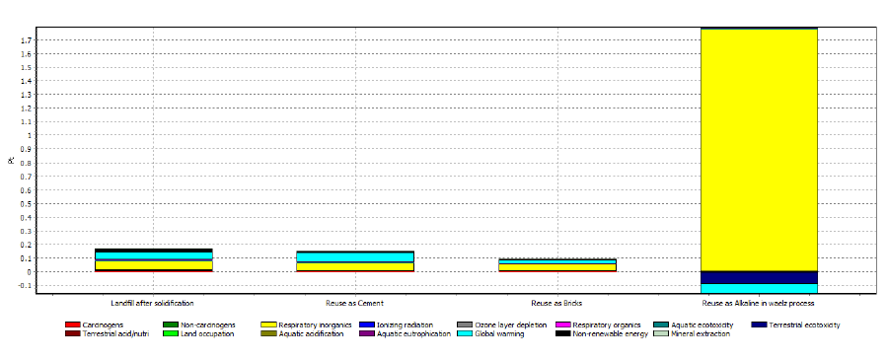
Figure: Comparison of the environmental impact between the four scenarios

Based on the environmental impact, this study assessed four scenarios to find the best treatment for fly ash. It was concluded that of the four options assessed, reusing fly ash as bricks was the most environmentally friendly treatment. In scenario 3, reuse as bricks, the hot spot of impact was in the washing process and pollution emission of the reuse process. Therefore, reducing the air pollution emission and finding a more efficient treatment for wastewater would be crucial to reduce the impact of this fly ash reuse method. However, this study cannot be considered as a complete assessment, as only one aspect of reuse treatment was evaluated. In future, we will also consider the cost-benefit and risk management aspects to select the best treatment for the reuse of fly ash (T.Y. Huanga, 2015).
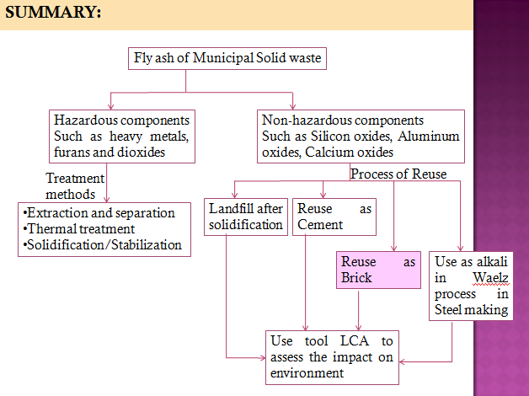
Figure: Graphical summary of the
Re-sue of Fly ash

8.1.2. RFID enhanced PAYT approach: A Case of United States.
Americans produce a staggering 254 billion tons of trash each year. This represents an approximate 300% increase over the past 50 years. And due to a wide range of economic, political and environmental factors, the number of landfills for all this “stuff” to be deposited into has markedly declined. There are already severe shortages of landfill space in pockets of the country. In fact, six states - Alaska, Connecticut, Delaware, North Carolina, New Hampshire and Rhode Island - have less than five years of landfill capacity remaining.
Single rate model:
Traditionally in the United States, trash collection has been a service performed by municipal governments - for a flat fee –for its citizens. The flat rate system provides no incentive for individuals to reduce the amount of waste they put out for collection. It is not inequitable, but actually harmful to the environment as well.
Pay As You Throw:
Then there was the introduction of “Pay As You Throw” (PAYT) system. Under the PAYT model, people pay a variable rate, based on the amount of trash they actually put out to be collected by the waste management contractor. Such long-standing PAYT systems have not gone without issues, including residents intentionally depositing their trash in other people’s containers (to avoid their own charges) and a limited rise in the illegal dumping or burning of trash in remote areas.

RFID enhanced PAYT model:
Then, came RFID enabled PAYT model which was the most efficient amongst all previous systems. Texas Instruments has been a leading proponent of using auto-ID technology to not just better the business intelligence of waste management contractors (enabling them to monitor their fleets and worker performance, both for optimizing routing and quality assurance, especially when combined with GPS that is already in wide use in the industry). Specially-equipped garbage trucks can then weigh each “smart” trash can upon collection, making it possible to ascertain the “net amount” of garbage collected from each customer each time each customer’s trash is gathered. The collection process can remain unchanged from what it is today, as the weighing is done as the can is lifted and emptied into the trash truck by the operator, thereby not slowing down the present system performance.
Municipal Solid Waste market holds the potential for rapid development over the next few years for RFID solutions providers, as well as those vendors providing the hardware and software necessary to support PAYT and for monitoring recycling. In fact, today’s economic conditions could work to benefit solutions providers in this area by accelerating the growth of both the PATY and recycling incentive programs, both in the U.S. and abroad (Wyld, 2010).
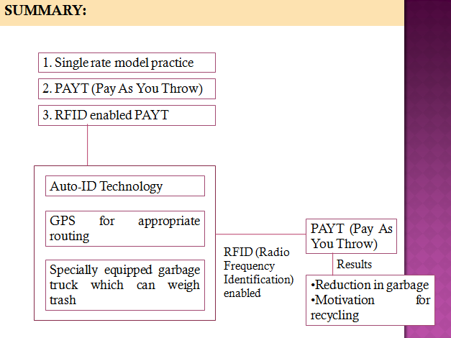
Figure: Graphical summary of the
Use of RFDI enhanced PAYT system

8.1.3. Selection of Hybrid Incineration and Gasification system: A Case of Maiked, Thailand.
Waste characterization:
To adopt the strategy of Hybrid Incineration and gasification, first an overview of composition of Municipal waste is required. Approximately 1 m3 of waste at the dumpsite was taken at Maiked as a sample for determining the physical and chemical composition. The physical composition of the waste, which is the main criteria for selecting the appropriate technology, was investigated. The results found was Similar to other rural areas in developing countries, the MSW generated in Maiked had a high percentage of organics waste (wet fraction), e.g. kitchen waste and yard waste, which amounted to 44.2 -wt. of the total. The remaining was a dry fraction, comprising plastic, paper, cloth, rubber and trace amounts of non-combustible material, e.g. glass, metal and hazardous waste (Kerdsuwana S, 2015).

Appropriate selection of technology:
Two cases were taken into account:
Case 1: The MSW could not be separated and all of the MSW was treated as mixed waste
Case 2: the MSW could be separated

Considering the selection criterion mentioned in of case 2, composting was the appropriate technology for wet fraction (organic waste) disposal since it is widely used and reliable, with no difficulty in operation. Based on viewpoint of economics, this technology requires low investment and operational costs. Additionally, it can be operated in the community households. Regarding the remainder from the separation process, which was referred to as the dry fraction, incineration was selected as the promising and ultimate technology to treat the dry waste since it can effectively reduce the volume of the mixed MSW, which has high flexibility for a non-homogeneous composition. This incineration technology has been commercially. However, this technology requires energy, normally from fossil fuel, for the combustion process in order to maintain the desired operating temperature; consequently, there are high operation costs. Hence, it is suggested that gasification technology be used in combination with incineration technology to produce producer gas, which can further be supplied in the incineration system as substitute fuel for fossil fuel. The conceptual design of the overall process for the MSW disposal technology, focusing on the incineration technology for dry waste, is illustrated in figure below:
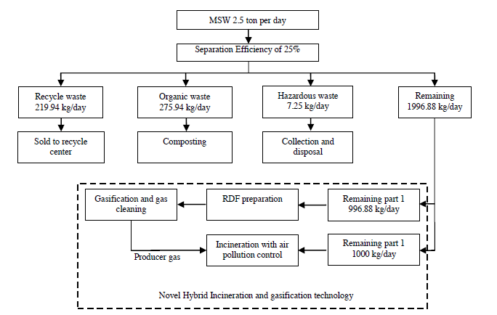
Figure: Conceptual design of the overall process for MSW disposal technology focusing on the novel hybrid incineration and gasification technology

The proper technology for the disposal of MSW in a rural area is controlled air incineration integrated with downdraft gasification. This combined technology has a dominant advantage in terms of reducing operation costs. The producer gas obtained from the gasification process can be used as a substitute for fossil fuel in the controlled air incinerator. The central government should support the LAO in terms of financial funds in order to invest in the necessary technology because MSW management is the responsibility of the government (Kerdsuwana S, 2015).
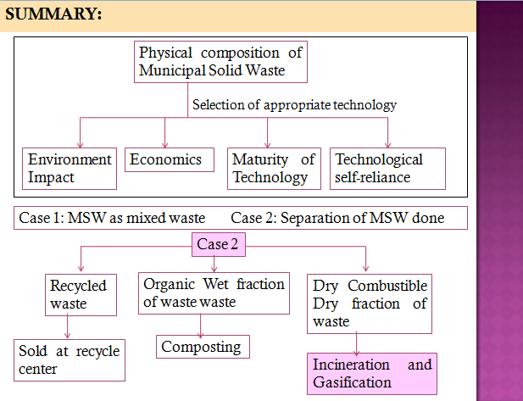
Figure: Graphical summary of selection of appropriate technology for sustainable approach to
municipal solid waste

9. Selection of appropriate approach for Kathmandu
From the literature which was carried out, it is clear that the approach to deal with the waste management varies according to economic, social, political factors of a country.
Since Nepal is a developing country, there are problems which are prevalent. Amongst all the problems such as public unawareness, poor management of waste etc, lack of funding come as a prominent problem. Hence, the approach which has taken into consideration the financial problem should be preferred and adopted. Amongst all the approaches that has been described, the hybrid system of incineration with gasification is most cost-effective.
Also, though Kathmandu city contains laws and regulations regarding solid waste management but they are not being practiced well. The prevailing laws are very generic and open ended. Thus, action has to be taken from the management perspective as well. Thus, RFID enhanced PAYT system seems to be effective in the context of Kathmandu but the cost-analysis has to be done for it to be applicable effectively.
The organic component in the solid waste in Kathmandu comprise of more than 50%. It includes higher amount of moisture content. Hence, the feasibility for incineration should also be assessed. Also, the approach to sustainable solid waste management in terms of re-use of fly ash does not seem to be viable in the context of Kathmandu as it requires more dry fraction of waste. The literature also reveals that the concept of reduction of solid waste at the first place is very effective strategy and hence that also could be adopted for Kathmandu valley.

10. Conclusion
Kathmandu being developing country, deals with the financial problems that gets reflected in the poor solid waste management system that is prevailing in the city. Thus, the approach for dealing with municipal solid waste sustainably which also admits the cost analysis basis should be adopted. The feasibility of the approaches should be properly examined before implementing to the specific city. Thus, for the Kathmandu city, composting, 3R’s concept to reduce the waste at the source and use of RFID enhanced PAYT system seems to be most suitable approach.
11. Recommendations
- Management authority should be active in implementing the laws and regulations effectively.
- Incentive to the individuals who practice recycling should be promoted.
- The end use of composting should have proper users.
- Reward giving system should be promoted who practice recycling process.

12. References
- Danish Eco City proves waste management can reverse greenhouse trend. (2009, November 26). Retrieved March 03, 2016, from EurekAlert.
- Kerdsuwana S, K. L. (2015). Sustainable Development and Eco-friendly Waste Disposal Technology for the Local Community.
- Rajbhandari US, N. A. (2014). Energy Consumption and Scenario Analysis of Residential Sector USing OPtimization Model - A Case of Kathmandu Valley.
- (2013). Solid Waste Management in Nepal. Asian Development Bank.
- T.Y. Huanga, P. C. (2015). Life cycle assessment of reusing fly ash from municipal solid waste incineration. Elsevier Ltd.
- Wyld, D. C. (2010). TAKING OUT THE TRASH (AND THE RECYCLABLES): RFID AND THE HANDLING OF MUNICIPAL SOLID WASTE.

